T.H.I.E.V.E.S.
A Pre­Reading Strategy

Strategy: THIEVES

Description
THIEVES is a pre-reading strategy that sets the purpose for reading using an easily remembered acronym. Students learn how to “steal” information from the Title, Headings, Introduction, Every first sentence, Visuals/Vocabulary, End-of- chapter questions, and Summary before reading the entire text selection. Using THIEVES helps readers to identify important concepts, establish a context for reading, and predict what ideas might be contained in a text passage.

Rationale for Using Pre-Reading Strategies in Science
Using a pre-reading strategy such as THIEVES enhances comprehension and retention of the information and ideas encountered during reading. Previewing helps the reader to create a "mental map" that can be used as the reader moves through the text (Learning Assistance and Resource Center, 2007). The mental map is based on the general structure of the text and helps guide the student during the reading process. Having mentally linked the textual clues, the reader is better able to follow the flow of ideas in the text and to detect the relationships among pieces of information.

Key Features/Functions
- Activating prior knowledge
- Using text and organizational features
- Establishing a purpose for reading
- Predicting
- Questioning
- Identifying main ideas
- Summarizing

Connections to Goals for Science Education (BC Science IRP)
Using a pre-reading strategy such as THIEVES addresses aspects of Goal 2 (Skills) and Goal 3 (Knowledge). Students are working collaboratively and making informed decisions while constructing understanding of science concepts.

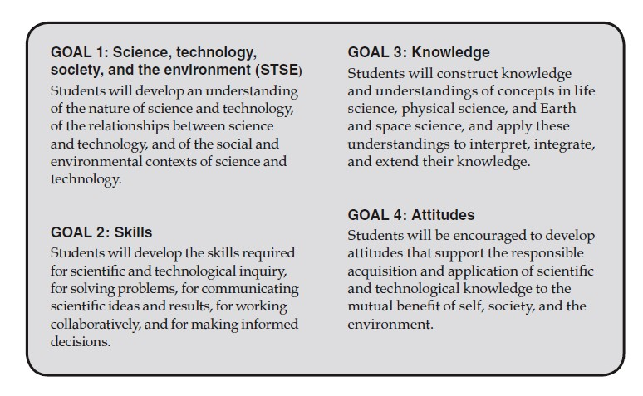

Ideas for Implementation

Science:
  - Predict possible meanings for the acronym THIEVES (see blackline master)
  - Introduce a unit, chapter, or lesson (orally with whole class, in pairs, or independently)
  - Use the bookmark to scaffold independent strategy use (student created or see attached template)
  - Complete a graphic organizer while using the strategy (standard and adapted - see attached)
  - Use the Jigsaw strategy – assign one element of THIEVES to each group (groups work on a different element each time, in order to gain a better understanding of the elements)

Cross Curricular Connections:
  - Can be used with any informational text – textbooks, magazines, National Geographic sets, newspapers, websites…

Interactive Whiteboard Connections:

- The Dual/Single Page Display (split screen) function allows blackline masters to be projected simultaneously with the text to be read.
- Text can be obtained from Science Probe CDs. Other informational text for projection can be obtained from Internet sites, scanned materials, or by using a document camera.
- Interactive whiteboards allow for drawing or writing directly on top of selected text or blackline master as the strategy is modeled.

Assessment
Informal assessment for learning is based on students’ ability to accurately and efficiently locate main ideas, make inferences, make connections to prior knowledge, establish a purpose for reading, and make predictions based on various text and organizational features when reading for information. Students might be asked to plan a strategic and efficient approach to reading a lengthy passage based on the THIEVES appraisal. Students might be asked to access and report their prior knowledge about a passage based on the THIEVES features. For example, students could predict specific ideas that might be contained in a text passage, without actually reading the entire passage.

Student Samples

8
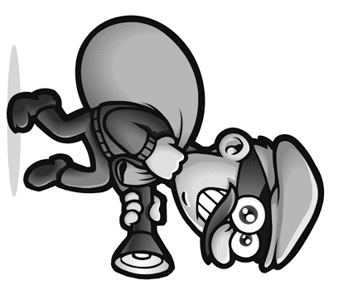

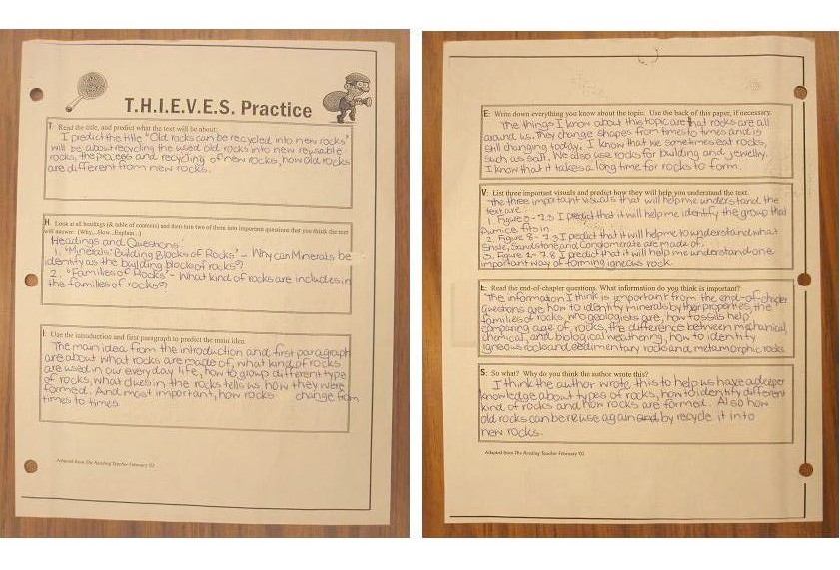

THIEVES graphic organizer – Grade 7 (Earth’s Crust)

9

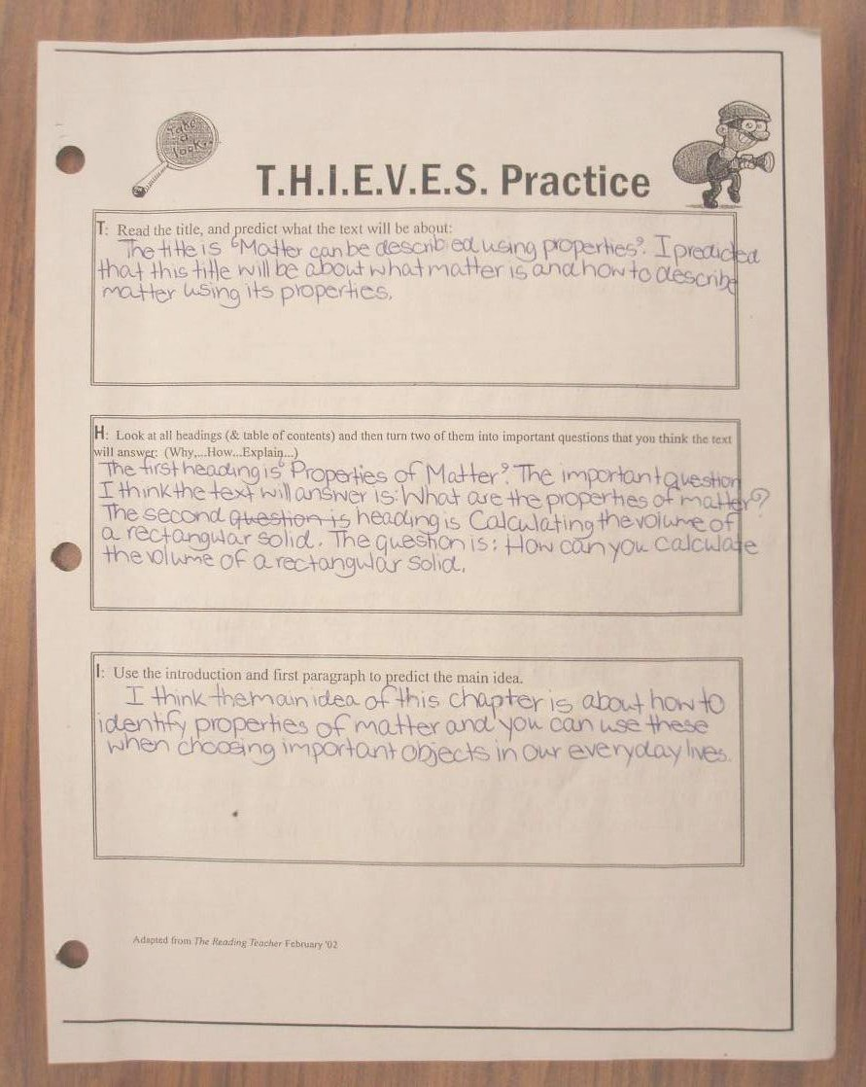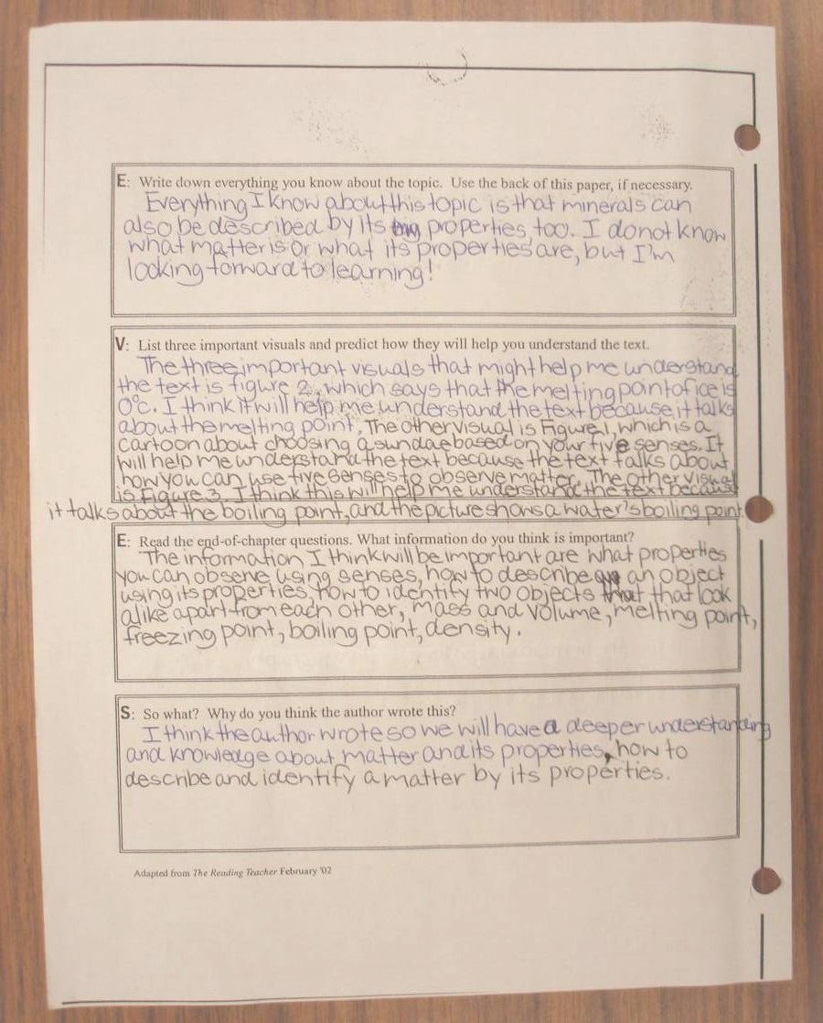

THIEVES graphic organizer – Grade 7 (Chemistry)

Related Articles

The following article can be found on the accompanying CD:

Manz, S.L. (2002). A strategy for previewing textbooks: Teaching readers to become THIEVES. The Reading Teacher, 55, 434–435. Retrieved from http://www.readwritethink.org/lesson_images/lesson112/manz.pdf

Blackline Masters

Becoming THIEVES

T

H

I

E

V

E

S

Copyright 2003 IRA/NCTE. All rights reserved. ReadWriteThink materials may be reproduced for educational purposes.

Title
The Elements of THIEVES

What is the title?
What do I already know about this topic?
What does this topic have to do with the preceding chapter? Does the title express a point of view?
What do I think I will be reading about?

Headings
What does this heading tell me I will be reading about? What is the topic of the paragraph beneath it?
How can I turn this heading into a question that is likely to be answered in the text?

Introduction
Is there an opening paragraph, perhaps italicized? Does the first paragraph introduce the chapter?
What does the introduction tell me I will be reading about? Do I know anything about this topic already?

Every first sentence in a paragraph
What do I think this chapter is going to be about based on the first sentence in each paragraph?

Visuals and vocabulary
Does the chapter include photographs, drawings, maps, charts, or graphs?
What can I learn from the visuals in a chapter?
How do captions help me better understand the meaning? Is there a list of key vocabulary terms and definitions?
Are there important words in boldface type throughout the chapter? Do I know what the boldfaced words mean?
Can I tell the meaning of the boldfaced words from the sentences in which they are embedded?

End-of-chapter questions
What do the questions ask?
What information do they earmark as important? What information do I learn from the questions?
Let me keep in mind the end-of-chapter questions so that I may annotate my text where pertinent information is located.

Summary
What do I understand and recall about the topics covered in the summary?

Copyright 2003 IRA/NCTE. All rights reserved. ReadWriteThink materials may be reproduced for educational purposes.

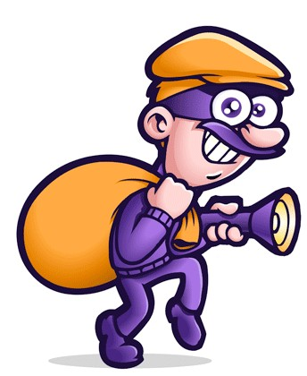
T.H.I.E.V.E.S.
Title
What is the title?
What do I already know about this topic?
What does this topic have to do with the preceding chapter? Does the title express a point of view?
What do I think I will be reading about?

Headings
What does this heading tell me I will be reading about?
What is the topic of the paragraph beneath it?
How can I turn this heading into a question that is likely to be answered in the text?

Introduction
Is there an opening paragraph, perhaps italicized?
Does the first paragraph introduce the chapter?
What does the introduction tell me I will be reading about?
Do I know anything about this topic already?

Every first sentence in a paragraph

What do I think this chapter is going to be about based on the first sentence in each paragraph?
T.H.I.E.V.E.S.
Title
What is the title?
What do I already know about this topic?
What does this topic have to do with the preceding chapter? Does the title express a point of view?
What do I think I will be reading about?

Headings
What does this heading tell me I will be reading about?
What is the topic of the paragraph beneath it?
How can I turn this heading into a question that is likely to be answered in the text?

Introduction
Is there an opening paragraph, perhaps italicized?
Does the first paragraph introduce the chapter?
What does the introduction tell me I will be reading about?
Do I know anything about this topic already?

Every first sentence in a paragraph

What do I think this chapter is going to be about based on the first sentence in each paragraph?
T.H.I.E.V.E.S.
Title
What is the title?
What do I already know about this topic?
What does this topic have to do with the preceding chapter? Does the title express a point of view?
What do I think I will be reading about?

Headings
What does this heading tell me I will be reading about?
What is the topic of the paragraph beneath it?
How can I turn this heading into a question that is likely to be answered in the text?

Introduction
Is there an opening paragraph, perhaps italicized?
Does the first paragraph introduce the chapter?
What does the introduction tell me I will be reading about?
Do I know anything about this topic already?

Every first sentence in a paragraph

What do I think this chapter is going to be about based on the first sentence in each paragraph?

Visuals and vocabulary
Does the chapter include photographs, drawings, maps, charts, or graphs?
What can I learn from the visuals in a chapter?
How do captions help me better understand the meaning?
Is there a list of key vocabulary terms and definitions?
Are there important words in boldface type throughout the chapter?
Do I know what the boldfaced words mean?
Can I tell the meaning of the boldfaced words from the sentences in which they are embedded?

End-of-chapter questions
What do the questions ask? What information do they earmark as important?
What information do I learn from the questions?
Let me keep in mind the end-of- chapter questions so that I may annotate my text where pertinent information is located.

Summary
What do I understand and recall about the topics covered in the summary?
Copyright 2003 IRA/NCTE. All
rights reserved. ReadWriteThink materials may be reproduced for educational purposes.
Visuals and vocabulary
Does the chapter include photographs, drawings, maps, charts, or graphs?
What can I learn from the visuals in a chapter?
How do captions help me better understand the meaning?
Is there a list of key vocabulary terms and definitions?
Are there important words in boldface type throughout the chapter?
Do I know what the boldfaced words mean?
Can I tell the meaning of the boldfaced words from the sentences in which they are embedded?

End-of-chapter questions
What do the questions ask? What information do they earmark as important?
What information do I learn from the questions?
Let me keep in mind the end-of- chapter questions so that I may annotate my text where pertinent information is located.

Summary
What do I understand and recall about the topics covered in the summary?
Copyright 2003 IRA/NCTE. All
rights reserved. ReadWriteThink materials may be reproduced for educational purposes.
Visuals and vocabulary
Does the chapter include photographs, drawings, maps, charts, or graphs?
What can I learn from the visuals in a chapter?
How do captions help me better understand the meaning?
Is there a list of key vocabulary terms and definitions?
Are there important words in boldface type throughout the chapter?
Do I know what the boldfaced words mean?
Can I tell the meaning of the boldfaced words from the sentences in which they are embedded?

End-of-chapter questions
What do the questions ask? What information do they earmark as important?
What information do I learn from the questions?
Let me keep in mind the end-of- chapter questions so that I may annotate my text where pertinent information is located.

Summary
What do I understand and recall about the topics covered in the summary?
Copyright 2003 IRA/NCTE. All
rights reserved. ReadWriteThink materials may be reproduced for educational purposes.

T.H.I.E.V.E.S.
Practice

T: Read the title, and predict what the text will be about:

H: Look at all headings (& table of contents) and then turn two of them into important questions that you think the text will answer: (Why,...How...Explain...)

I: Use the introduction and first paragraph to predict the main idea.

E: Write down everything you know about the topic. Use the back of this paper, if necessary.

V: List three important visuals and predict how they will help you understand the text.

E: Read the end-of-chapter questions. What information do you think is important?

S: Summary – so what? Why do you think the author wrote this?

THIEVES Practice

T | What is the Title of the Chapter? What do you think you will be learning about?
H | List three Headings: 1.  2.  3.
I | Read the first (Introductory) paragraph. Write down anything you already know about this topic.
E | Read Each of the key ideas listed at the beginning of the chapter. What have you learned?
V | Describe two Visuals. How do you think they will help you understand the text?  pg. pg.
E | Write one of the End of the chapter questions below:
S | Read the Summary section at the end of the chapter.

References (THIEVES)
Learning Assistance and Resource Center. (2007). Retrieved from http://larc.asp.radford.edu/previewing_science_chapters.asp

Manz, S.L. (2002). A strategy for previewing textbooks: Teaching readers to become THIEVES. The Reading Teacher, 55, 434–435. Retrieved from http://www.readwritethink.org/lesson_images/lesson112/manz.pdf

Ministry of Education, Province of British Columbia. (2005). Science K to 7: Integrated resource package 2005. Retrieved from http://www.bced.gov.bc.ca/irp/irp_sci.htm.

ReadWriteThink. (2007). Using THIEVES to preview nonfiction texts. Retrieved from http://www.readwritethink.org/lessons/lesson_view.asp?id=112

